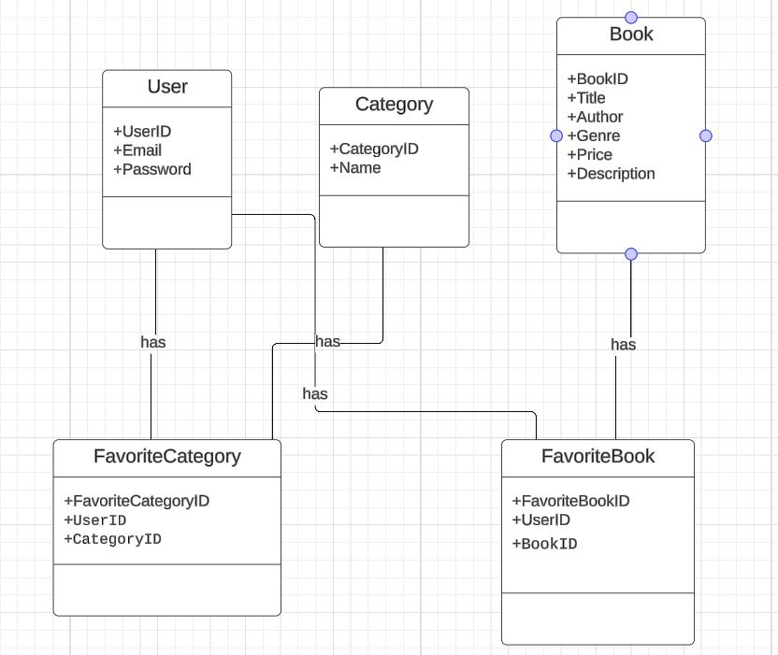

**Logic schema:**

User (UserID, Email, Password)

PK: UserID

Book (BookID, Title, Author, Genre, Price, Description)

PK: BookID

Category (CategoryID, Name)

**PK**: CategoryID

FavoriteCategory (FavoriteCategoryID, UserID, CategoryID)

PK: FavoriteCategoryID

FK: UserID

FK: CategoryID

FavoriteBook (FavoriteBookID, UserID, BookID)

PK: FavoriteBookID

FK: UserID

FK: BookID